**Mongo DB Document DB**

Open mongo shell from cmd

Use e-commerse

Create collection users and insert bulk records using following commands

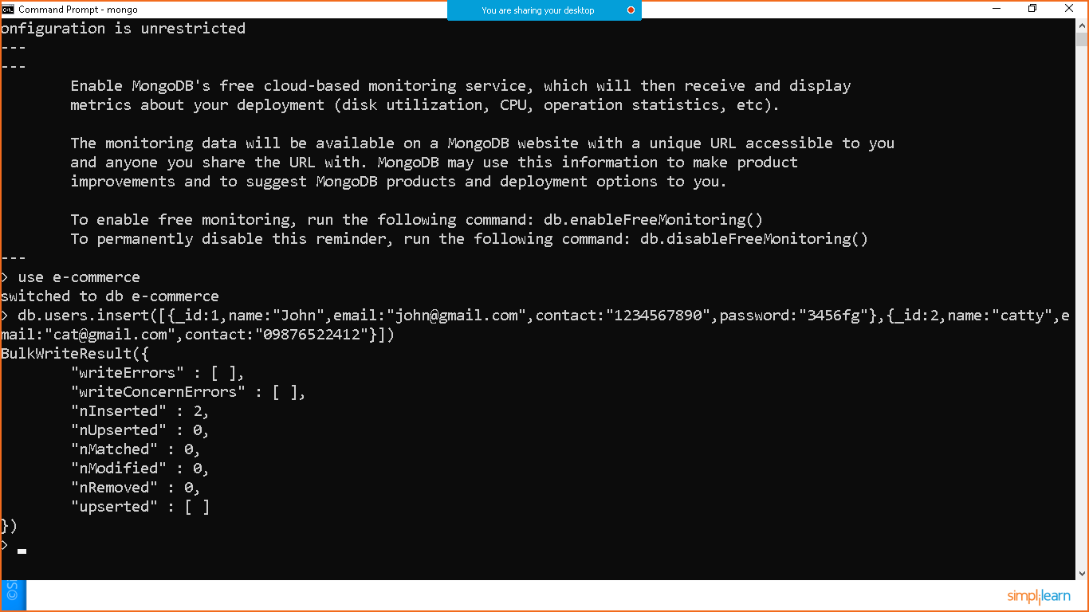

To fetch all records

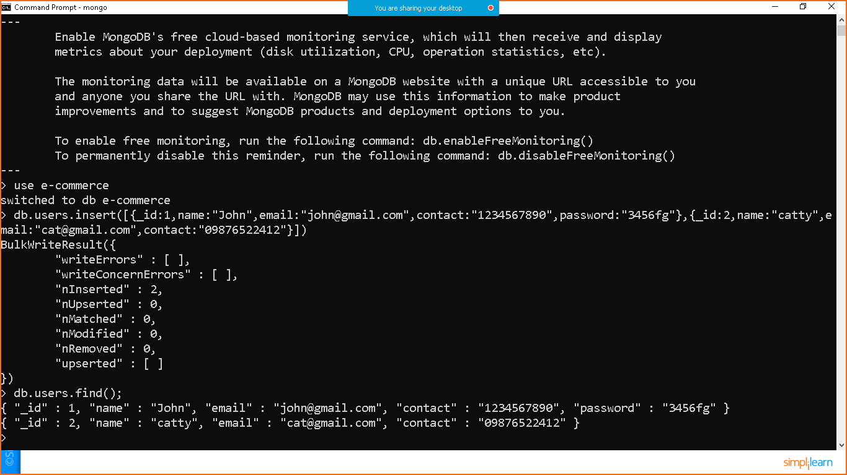

To fetch all records in pretty way.

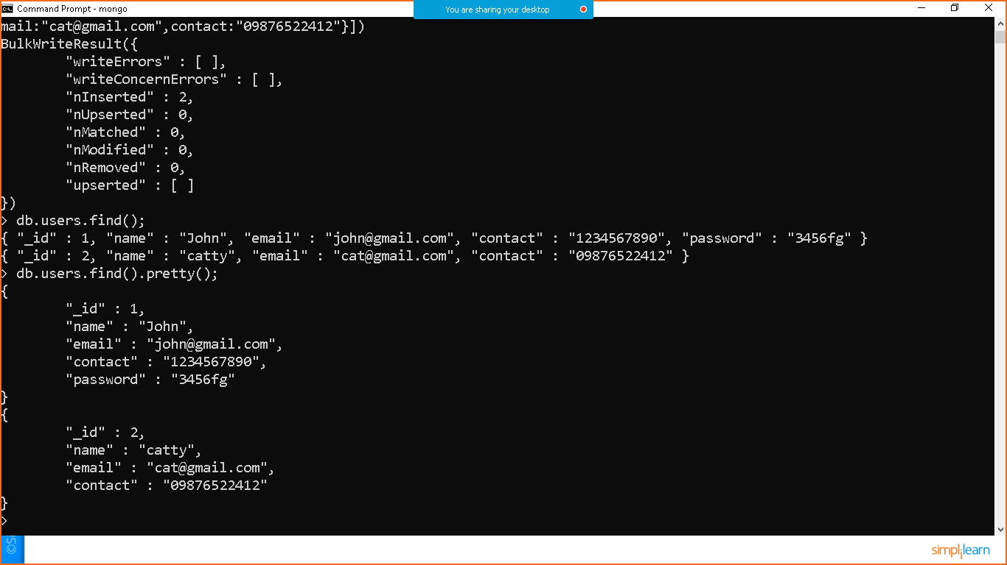

To fetch a single record

